Exercise 1: Ranking and Window Functions:
Code:
CREATE TABLE Products (
ProductID INTEGER PRIMARY KEY,
ProductName TEXT,
Category TEXT,
Price DECIMAL(10,2)
);
INSERT INTO Products (ProductName, Category, Price) VALUES
('Laptop Pro', 'Electronics', 1200.00),
('Smartphone X', 'Electronics', 800.00),
('4K Monitor', 'Electronics', 400.00),
('Gaming Console', 'Electronics', 400.00), -- Tie price to test RANK vs DENSE_RANK
('Bluetooth Speaker', 'Electronics', 150.00),
('Ergonomic Chair', 'Furniture', 350.00),
('Standing Desk', 'Furniture', 500.00),
('Bookshelf', 'Furniture', 200.00),
('Office Lamp', 'Furniture', 50.00),
('Running Shoes', 'Apparel', 120.00),
('Winter Jacket', 'Apparel', 200.00),
('Designer Jeans', 'Apparel', 150.00),
('T-Shirt', 'Apparel', 25.00);
WITH RankedProducts AS (
SELECT
Category,
ProductName,
Price,
ROW_NUMBER() OVER (PARTITION BY Category ORDER BY Price DESC) AS RowNum,
RANK() OVER (PARTITION BY Category ORDER BY Price DESC) AS RankNum,
DENSE_RANK() OVER (PARTITION BY Category ORDER BY Price DESC) AS DenseRankNum
FROM Products
)
SELECT * FROM RankedProducts
WHERE DenseRankNum <= 3; -- Filters for top 3 per category based on dense rank

Output:
Exercise 1: Ranking and Window Functions:
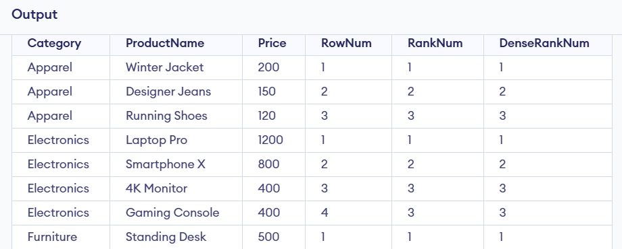

Exercise 2: Create a Stored Procedure
Code:
SQL> CREATE OR REPLACE PROCEDURE sp_GetEmployeesByDepartment

p_DepartmentID IN NUMBER
)
AS
BEGIN
FOR emp_rec IN (
SELECT EmployeeID,
FirstName,
LastName
FROM Employees
WHERE DepartmentID = p_DepartmentID
)
LOOP
DBMS_OUTPUT.PUT_LINE(
emp_rec.EmployeeID || ' ' ||
emp_rec.FirstName || ' ' ||
emp_rec.LastName
);
END LOOP;
END;
/

employee table
Output:
EMPLOYEEID FIRSTNAME LASTNAME DEPARTMENTID SALARY JOINDATE
---------- --------- -------- ------------ ------ ----------
1 Alice Joe 11 51000 16-JAN-25
2 Joe Smith 20 70000 19-JUN-22
3 Mike Thomson 10 55000 20-MAY-25

Exercise 3: Return Data from a Stored Procedure
Code:
SQL> CREATE OR REPLACE PROCEDURE sp_GetEmployeeCount

p_DepartmentID IN NUMBER,
p_TotalEmployees OUT NUMBER
)
AS
BEGIN
SELECT COUNT(*)
INTO p_TotalEmployees
FROM Employees
WHERE DepartmentID = p_DepartmentID;
END;
/

Procedure created.

SQL> VARIABLE total_count NUMBER;
SQL> EXEC sp_GetEmployeeCount(10, :total_count);

PL/SQL procedure successfully completed.

SQL> PRINT total_count;

TOTAL_COUNT
-----------
1

